**Section 1**

**Determining correct file format**

|  |  |
| --- | --- |
| **File Name** | **File Type** |
| **File1** | **DOC** |
| **File2** | **PDF** |
| **File3** | **BMP** |
| **File4** | **JPEG** |

**Section 2**

**Recover .png file**

* 

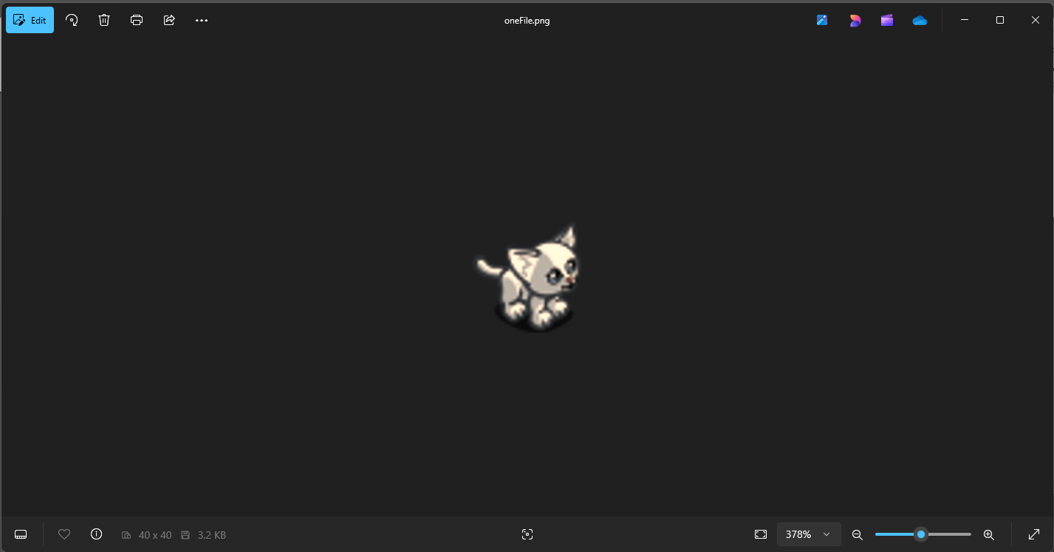

* Actual file is in uploaded folder

**Section 3**

**Carving**

* 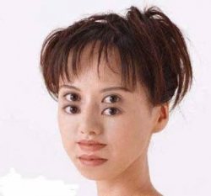
* .wav file is in uploaded folder

**Section 4**

**Determine the correct file type and file extensions for each file**

|  |  |
| --- | --- |
| **File Name** | **Discovered File Type** |
| **File 1** | **GIF - GIF89a bitmap** |
| **File 2** | **EXE - Win16 NE executable (generic)** |
| **File 3** | **PDF – Adobe Portable Document Format** |
| **File 4** | **DOC – Generic OLE2 / Multistream Compound** |
| **File 5** | **JPG/JPEG – JFIF JPEG bitmap** |
| **File 6** | **WAV – RIFF/WAVe standard audio** |